Assignment 25.4

1.Write a hive query to find the top 20 destination people travel the most: Based on the given data

2. Write a hive query to find the top 20 locations from where people travel the most

Travel Sector Dataset Description

Column 1: City pair (Combination of from and to): String Column 2: From location: String Column 3: To Location: String Column 4: Product type: Integer (1=Air, 2=Car, 3 =Air+Car, 4 =Hotel, 5=Air+Hotel, 6=Hotel +Car, 7 =Air+Hotel+Car) Column 5: Adults traveling: Integer Column 6: Seniors traveling: Integer Column 7: Children traveling: Integer Column 8: Youth traveling: Integer Column 9: Infant traveling: Integer Column 10: Date of travel: String Column 11: Time of travel: String Column 12: Date of Return: String Column 13: Time of Return: String Column 14: Price of booking: Float Column 15: Hotel name: String

1.Write a hive query to find the top 20 destination people travel the most:

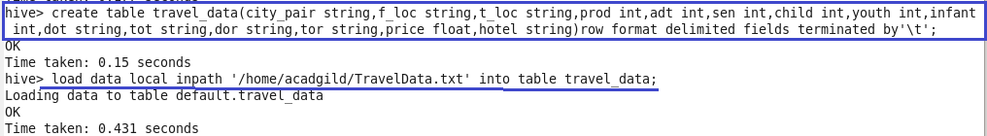



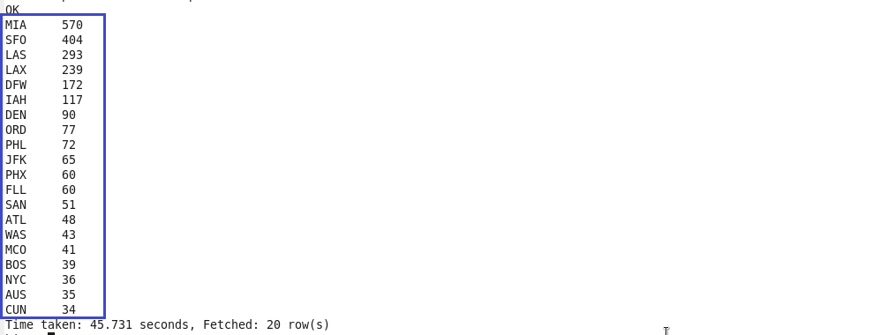

2. Write a hive query to find the top 20 locations from where people travel the most



